**Mild to Moderate evaluation**

Sample_ID: **HMKTVX (Dog)**

Link**:** [**https://release.animalbiome.com/pet/assessment/report/0ee0a63b-9d4a-4aa2-95b9-86ec5dcf27e9**](https://release.animalbiome.com/pet/assessment/report/0ee0a63b-9d4a-4aa2-95b9-86ec5dcf27e9)

Cats and dogs:

Any Two

(High Yellow Flag Megamonas OR (failed)

High Yellow Flag Sutterella OR (failed)

High Yellow Flag Collinsella OR (failed)

Low Yellow Flag Bacteroides OR (**passed**)

Low Yellow Flag Blautia (**passed**)

)

OR

OR Dogs: 4-7 Yellow Flags (failed)

OR 5-7 Red Flags; (failed)

OR diet recommendation of increase fibre (**passed**)

OR diet recommendation of increase protein (failed)



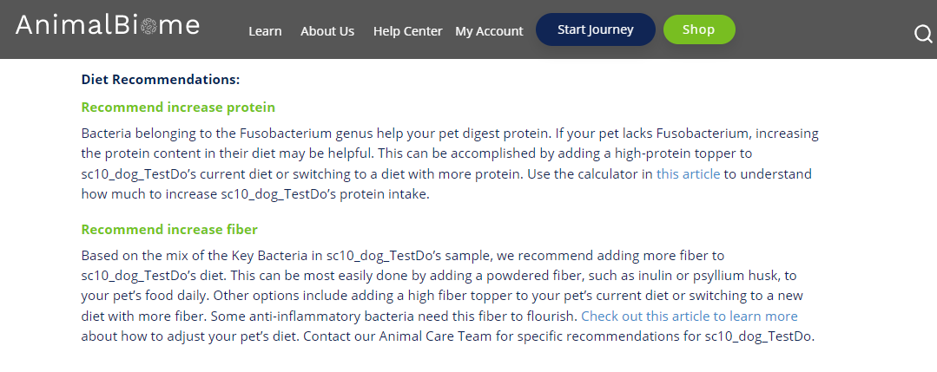

The result : True False False True.

Expected result : Mild to moderate

Acheived result : **passed**.

